Grocery Shop Management System

horizontal line

# Introduction

Grocery Shop Management System primarily focuses for retail Grocery shops whose owners are still manually manage the inventory which requires a lot effort and time as well. The purpose of this project is to develop the system in such a way that naive person can do the management of the stock without prior knowledge of accounts and he/she can require to hire a person who do this task and inform the retail shop owner about the stock.

The central goal of the project was to manage the stock and provides the useful information like daily total sale and purchase, current stock etc. As the product was focused for retail shop owners, we decided to build the desktop offline version which is economically fair for them as well. That’s why we have used Flat UI for App Designing and C# for business logic.

Grocery Management System is a system that helps owner to manage stock in efficient way. The purpose of this project to develop Grocery Shop management System that can analyse the stock status like daily purchase/sell and list of customers.

In today’s time things goes very complex and hard to manage with the help of only human effort where technology comes in the picture which helps managing the stock on regular bases and want to know daily stock transactions is a bit complex and time consuming where Grocery Shop Management System can help.

First, the system stores data of all products on the bases of Category. The system also stores the information of our stock - Customers like their basic info and contact info. The system also shows the daily transaction on the basis of sell and purchase. The system also generates the report on the basis of days and also for a entire time period. With the help of this system shop owner can get appropriate information about stocks and can take proper decisions like when they should order new goods for stock, which category peoples like to buy usually. Also purchase and sale report helps owner to track individual track of purchase and sale with exact date.

System Module

1. **Registration :** the main purpose of thisRegistration module is to provide an authentication, admin must have to registered himself before Accessing the System.after registering admin can access all features of the System
2. **Login :** After registration one will register within the system because of the operator of the system either on behalf of the user. When this he has the different helpful interfaces accessible for any actions.
3. **Admin :** Admin has the official powers to control the flow of the data from one part of the system to the other. He can manipulate the access of the users to the data.The primary purpose of this account is to make the user data relevant and then giving the inputs to the other interface module and make it work optimistically and get the timetable according to the wish we want to create for a particular type of inputs.
4. **Product :** Admin has the official power to do CRUD(**C**reate,**R**ead,**U**pdate,**D**elete) operation on Product**.**Admin can also manage stock of products
5. **Order :** The things which choose by the user then move to order interface to get ordered by the user as he will see here the details of the final result to order the total and date.
6. **Payment :** System Provides Cash On Delivery Payment Service in which Customer have to Pay Amount after Delivery
7. **Report :** Admin can generate different types of Reports to track the available Products, Customer, Stock, Invoice etc.

System Features

1. System is allowed to Manage Product ( CRUD Operation )
2. System is allowed to Manage Customer( CRUD Operation )
3. System is allowed to Add Category
4. System is allowed to see list of Available Product
5. System is allowed to see Available Stock
6. System is allowed to Generate Different types of Reports
7. System is allowed to see Sales of Product daywise
8. System is allowed to See list of Customer
9. System is allowed to see Available Stock
10. System is allowed to Generate Different types of Reports
11. System is allowed to generate a Warning if Product Expiry Date is nearer to selected Invoice Date

# Tools and Technology

1. **Flat UI:** Flat design is a minimalist user interface design genre, or design language, commonly used in graphical user interfaces, and also in such graphical materials as posters, arts, guide documents and publishing products
2. **ASP .NET : .**NET Framework is a software framework developed by Microsoft that runs primarily on Microsoft Windows. It includes a large class library named as Framework Class Library and provides language interoperability across several programming languages..
3. **MYSQL:** SQL is a domain-specific language used in programming and designed for managing data held in a relational database management system, or for stream processing in a relational data stream management system.
4. **Git and Github:** Git is a version control system and GitHub helps to save repo online.

# Source Code

# using System; //Home.cs

# using System.Collections.Generic;

# using System.ComponentModel;

# using System.Data;

# using System.Drawing;

# using System.Linq;

# using System.Text;

# using System.Windows.Forms;

# using System.Data.SqlClient;

# 

# namespace GroceryShop

# {

# public partial class Home : Form

# {

# public Home()

# {

# InitializeComponent();

# }

# int id;

# int amount = 0;

# 

# private void Form1_Load(object sender, EventArgs e)

# {

# lblerrmsg.Visible = false;

# btnproducts.Enabled = false;

# btncat.Enabled = false;

# btnreports.Enabled = false;

# btninv.Enabled = false;

# btncust.Enabled = false;

# 

# this.productTableAdapter.Fill(this.groceryDataSetInvPro.Product);

# p1.Visible = false;

# p2.Visible = false;

# p3.Visible = false;

# p4.Visible = false;

# p5.Visible = false;

# 

# pinvoice.Visible = false;

# panelinvoice.Visible = false;

# lbldays.Visible = false;

# txtTotalAmount.Visible = false;

# txtinstock.Visible = false;

# lbldays.Visible = false;

# pcategory.Visible = false;

# pcustomer.Visible = false;

# pproduct.Visible = false;

# txtcnamecb.Enabled = false;

# lblcbid.Visible = false;

# lblcbname.Visible = false;

# comboBoxname.Visible = false;

# lblx.Visible = false;

# txtqty.Visible = false;

# txttotalweight.Visible = false;

# comboBoxdelete.Visible = false;

# label9.Visible = false;

# }

# 

# /// <summary>

# /// login

# /// </summary>

# /// <param name="sender"></param>

# /// <param name="e"></param>

# private void btnlogin_Click(object sender, EventArgs e)

# {

# lblerrmsg.Visible = true;

# 

# if (txtusername.Text == "admin" && txtpasswrd.Text == "admin")

# {

# lblerrmsg.Text = " Logged In...!";

# btnproducts.Enabled = true;

# btncat.Enabled = true;

# btnreports.Enabled = true;

# btninv.Enabled = true;

# btncust.Enabled = true;

# txtusername.Clear();

# txtpasswrd.Clear();

# }

# else

# {

# lblerrmsg.Text = "Invalid username & password..!";

# txtpasswrd.Clear();

# txtusername.Clear();

# }

# }

# private void btncust_Click(object sender, EventArgs e)

# {

# plogin.Visible = false;

# pproduct.Visible = false;

# pinvoice.Visible = false;

# pcategory.Visible = false;

# pcustomer.Visible = true;

# }

# 

# /// <summary>

# /// customer

# /// </summary>

# /// <param name="sender"></param>

# /// <param name="e"></param>

# private void btnadd_Click(object sender, EventArgs e)

# {

# // sql database connection & open

# SqlConnection cn = new SqlConnection("Data Source=.\\SQLEXPRESS;AttachDbFilename=D:\\MCA\\GroceryShop\\GroceryShop\\Grocery.mdf;Integrated Security=True;Connect Timeout=30;User Instance=True");

# cn.Open();

# 

# // insert data query

# string insert = "insert into Customer values(@Name,@MobileNO,@EMail,@Address,@Gender)";

# 

# // add values into table

# SqlCommand cmd = new SqlCommand(insert, cn);

# cmd.Parameters.AddWithValue("@Name", txtname.Text);

# cmd.Parameters.AddWithValue("@MobileNO", txtmobile.Text);

# cmd.Parameters.AddWithValue("@EMail", txtemail.Text);

# cmd.Parameters.AddWithValue("@Address", txtadd.Text);

# cmd.Parameters.AddWithValue("@Gender", comboBox1.SelectedItem);

# cmd.ExecuteNonQuery();

# 

# // close connection

# cn.Close();

# 

# // clear text

# txtname.Clear();

# txtmobile.Clear();

# txtadd.Clear();

# txtemail.Clear();

# comboBox1.SelectedText = "";

# 

# // focus on name TextBox Name

# txtname.Focus();

# }

# private void comboBox2_SelectedIndexChanged(object sender, EventArgs e)

# {

# 

# }

# private void btnupdate_Click(object sender, EventArgs e)

# {

# // sql database connection & open

# SqlConnection cn = new SqlConnection("Data Source=.\\SQLEXPRESS;AttachDbFilename=D:\\MCA\\GroceryShop\\GroceryShop\\Grocery.mdf;Integrated Security=True;Connect Timeout=30;User Instance=True");

# cn.Open();

# 

# // update data query

# string update = "update Customer set Name='" + txtname.Text + "',MobileNo='" + txtmobile.Text + "',EMail='" + txtemail.Text + "',Address='" + txtadd.Text

# + "',Gender='" + comboBox1.SelectedItem + "'where ID='" + comboBox2.Text + "'";

# 

# // update values from table

# SqlCommand cmd = new SqlCommand(update, cn);

# cmd.ExecuteNonQuery();

# 

# // close connection

# cn.Close();

# 

# // clear text

# txtname.Clear();

# txtmobile.Clear();

# txtemail.Clear();

# txtadd.Clear();

# comboBox2.Refresh();

# // focus on name TextBox Name

# txtname.Focus();

# }

# 

# private void btnremove_Click(object sender, EventArgs e)

# {

# // sql database connection & open

# SqlConnection cn = new SqlConnection("Data Source=.\\SQLEXPRESS;AttachDbFilename=D:\\MCA\\GroceryShop\\GroceryShop\\Grocery.mdf;Integrated Security=True;Connect Timeout=30;User Instance=True");

# cn.Open();

# 

# // delete data query

# string delet = "delete from Customer where ID='" + comboBox2.Text + "'";

# 

# // delete values from table

# SqlCommand cmd = new SqlCommand(delet, cn);

# cmd.ExecuteNonQuery();

# 

# // close connection

# cn.Close();

# 

# // clear text

# txtname.Clear();

# txtmobile.Clear();

# txtemail.Clear();

# txtadd.Clear();

# comboBox2.Refresh();

# // focus on name TextBox Name

# txtname.Focus();

# }

# 

# /// <summary>

# /// products

# /// </summary>

# /// <param name="sender"></param>

# /// <param name="e"></param>

# private void btnproducts_Click(object sender, EventArgs e)

# {

# plogin.Visible = false;

# pcustomer.Visible = false;

# pinvoice.Visible = false;

# pcategory.Visible = false;

# pproduct.Visible = true;

# }

# 

# private void button3_Click_1(object sender, EventArgs e)

# {

# btnimgupd.Enabled = true;

# // sql database connection & open

# SqlConnection cn = new SqlConnection("Data Source=.\\SQLEXPRESS;AttachDbFilename=D:\\MCA\\GroceryShop\\GroceryShop\\Grocery.mdf;Integrated Security=True;Connect Timeout=30;User Instance=True");

# cn.Open();

# 

# // insert data query

# string insert = "insert into Product values(@Name,@Category,@Description,@SellPrice,@CostPrice,@Image,@Unit,@Quantity,@totalWeight,@ExpireDay)";

# 

# int total;

# int qty = System.Convert.ToInt32(txtqty.Text);

# 

# if (cbunit.Text == "Box(50 Item)")

# {

# total = 50 * qty;

# txttotalweight.Text = total.ToString();

# }

# else if (cbunit.Text == "Kattu(50 Kg)")

# {

# total = 50 * qty;

# txttotalweight.Text = total.ToString();

# }

# else if (cbunit.Text == "Dabba(15 ltr)")

# {

# total = 15 * qty;

# txttotalweight.Text = total.ToString();

# }

# else if (cbunit.Text == "Pouch(50 piece)")

# {

# total = 50 * qty;

# txttotalweight.Text = total.ToString();

# }

# // add values into table

# SqlCommand cmd = new SqlCommand(insert, cn);

# cmd.Parameters.AddWithValue("@Name", txtPname.Text);

# cmd.Parameters.AddWithValue("@Description", txtdesc.Text);

# cmd.Parameters.AddWithValue("@Category", cbcat.SelectedValue);

# cmd.Parameters.AddWithValue("@SellPrice", txtsell.Text);

# cmd.Parameters.AddWithValue("@CostPrice", txtpurc.Text);

# cmd.Parameters.AddWithValue("@Image", productimg.ImageLocation);

# cmd.Parameters.AddWithValue("@Unit", cbunit.Text);

# cmd.Parameters.AddWithValue("@Quantity", txtqty.Text);

# cmd.Parameters.AddWithValue("@totalWeight", txttotalweight.Text);

# cmd.Parameters.AddWithValue("@ExpireDay", dtpexp.Text);

# cmd.ExecuteNonQuery();

# 

# // close connection

# cn.Close();

# 

# // clear text

# txtname.Clear();

# cbcat.Text = "";

# txtdesc.Clear();

# txtsell.Clear();

# txtpurc.Clear();

# txtPname.Clear();

# cbunit.Text = "";

# txtqty.Clear();

# txttotalweight.Clear();

# productimg.Refresh();

# cbcat.Text = "--select--";

# cbunit.Text = "--select--";

# dtpexp.Text = "";

# // focus on name TextBox Name

# txtname.Focus();

# MessageBox.Show("Added...");

# }

# 

# private void button2_Click_1(object sender, EventArgs e)

# {

# // sql database connection & open

# SqlConnection cn = new SqlConnection("Data Source=.\\SQLEXPRESS;AttachDbFilename=D:\\MCA\\GroceryShop\\GroceryShop\\Grocery.mdf;Integrated Security=True;Connect Timeout=30;User Instance=True");

# cn.Open();

# 

# // update data query

# int total;

# int qty = System.Convert.ToInt32(txtqty.Text);

# 

# if (cbunit.Text == "Box(50 Item)")

# {

# total = 50 * qty;

# txttotalweight.Text = total.ToString();

# }

# else if (cbunit.Text == "Kattu(50 Kg)")

# {

# total = 50 * qty;

# txttotalweight.Text = total.ToString();

# }

# else if (cbunit.Text == "Dabba(15 ltr)")

# {

# total = 15 * qty;

# txttotalweight.Text = total.ToString();

# }

# else if (cbunit.Text == "Pouch(50 piece)")

# {

# total = 50 * qty;

# txttotalweight.Text = total.ToString();

# }

# 

# string update = "update Product set Name='" + txtPname.Text + "',Category='" + cbcat.SelectedValue + "',Description='" + txtdesc.Text + "',SellPrice='" + txtsell.Text

# + "',CostPrice='" + txtpurc.Text + "',Image='" + productimg.Location + "',Unit='" + cbunit.Text + "',Quantity='" + txtqty.Text

# + "',totalWeight='" + txttotalweight.Text + "',ExpireDay='" + dtpexp.Text + "'where ID='" + comboBoxdelete.Text + "'";

# 

# // update values from table

# SqlCommand cmd = new SqlCommand(update, cn);

# cmd.ExecuteNonQuery();

# 

# // close connection

# cn.Close();

# 

# // clear text

# txtPname.Text = "";

# cbcat.Text = "";

# txtdesc.Clear();

# txtsell.Clear();

# txtpurc.Clear();

# cbunit.Text = "";

# txtqty.Clear();

# txttotalweight.Clear();

# productimg.ResetText();

# cbcat.Text = "--select--";

# cbunit.Text = "--select--";

# dtpexp.Text = "";

# // focus on name TextBox Name

# txtname.Focus();

# MessageBox.Show("Updated...");

# }

# 

# private void button1_Click_1(object sender, EventArgs e)

# {

# // sql database connection & open

# SqlConnection cn = new SqlConnection("Data Source=.\\SQLEXPRESS;AttachDbFilename=D:\\MCA\\GroceryShop\\GroceryShop\\Grocery.mdf;Integrated Security=True;Connect Timeout=30;User Instance=True");

# cn.Open();

# 

# // delete data query

# string delet = "delete from Product where ID='" + comboBoxdelete.Text + "'";

# 

# // delete values from table

# SqlCommand cmd = new SqlCommand(delet, cn);

# cmd.ExecuteNonQuery();

# 

# // close connection

# cn.Close();

# 

# // clear text

# comboBoxdelete.Text = "";

# comboBoxname.Text = "";

# // focus on name TextBox Name

# txtname.Focus();

# MessageBox.Show("Your Product is deleted successfully");

# }

# private void comboBoxname_SelectedIndexChanged(object sender, EventArgs e)

# {

# comboBoxname.Visible = true;

# }

# 

# private void cbunit_SelectedIndexChanged(object sender, EventArgs e)

# {

# lblx.Visible = true;

# txtqty.Visible = true;

# }

# 

# private void btnupdate_MouseMove(object sender, MouseEventArgs e)

# {

# btnadd.Enabled = false;

# btnremove.Enabled = false;

# comboBoxdelete.Visible = true;

# label9.Visible = true;

# }

# 

# private void btnremove_MouseMove(object sender, MouseEventArgs e)

# {

# btnadd.Enabled = false;

# btnupdate.Enabled = false;

# comboBoxdelete.Visible = true;

# label9.Visible = true;

# comboBoxdelete.Focus();

# // clear text

# txtname.Enabled = false;

# cbcat.Enabled = false;

# txtdesc.Enabled = false;

# txtsell.Enabled = false;

# txtpurc.Enabled = false;

# cbunit.Enabled = false;

# txtqty.Enabled = false;

# txttotalweight.Enabled = false;

# btnimgupd.Enabled = false;

# cbcat.Enabled = false;

# cbunit.Enabled = false;

# dtpexp.Enabled = false;

# }

# private void btnadd_MouseMove(object sender, MouseEventArgs e)

# {

# btnupdate.Enabled = false;

# btnremove.Enabled = false;

# }

# private void btnreports_Click_1(object sender, EventArgs e)

# {

# ReportCard rc = new ReportCard();

# rc.Show();

# }

# 

# private void btncat_Click(object sender, EventArgs e)

# {

# plogin.Visible = false;

# pcustomer.Visible = false;

# pproduct.Visible = false;

# pinvoice.Visible = false;

# pcategory.Visible = true;

# }

# 

# private void btnaddcat_Click(object sender, EventArgs e)

# {

# // sql database connection & open

# SqlConnection cn = new SqlConnection("Data Source=.\\SQLEXPRESS;AttachDbFilename=D:\\MCA\\GroceryShop\\GroceryShop\\Grocery.mdf;Integrated Security=True;Connect Timeout=30;User Instance=True");

# cn.Open();

# 

# // insert data query

# string insert = "insert into Category values(@Category)";

# 

# // add values into table

# SqlCommand cmd = new SqlCommand(insert, cn);

# cmd.Parameters.AddWithValue("@Category", txtaddCat.Text);

# cmd.ExecuteNonQuery();

# 

# // close connection

# cn.Close();

# 

# // clear text

# txtaddCat.Clear();

# 

# // focus on name TextBox Name

# txtaddCat.Focus();

# MessageBox.Show("Added...!");

# }

# 

# private void btninv_Click_1(object sender, EventArgs e)

# {

# plogin.Visible = false;

# pproduct.Visible = false;

# pcustomer.Visible = false;

# pcategory.Visible = false;

# pinvoice.Visible = true;

# }

# private DataTable get()

# {

# DataTable tab = new DataTable();

# SqlConnection cn = new SqlConnection("Data Source=.\\SQLEXPRESS;AttachDbFilename=D:\\MCA\\GroceryShop\\GroceryShop\\Grocery.mdf;Integrated Security=True;Connect Timeout=30;User Instance=True");

# cn.Open();

# DateTime d = DateTime.Now;

# string dates = d.ToString("MM/dd/yyyy").ToString();

# // insert data query

# //string sel = "select ProductID,ProductName,Price,Quantity,TotalPrice from Invoice where CustID='" + System.Convert.ToInt32(comboBox2.Text) + "'" + "' ORDER BY Price";

# 

# SqlCommand cmd = new SqlCommand("select ProductID,ProductName,Price,Quantity,TotalPrice from Invoice where CustID='" + System.Convert.ToInt32(txtICID.Text) + "' and Date='" + dateTimePicker1.Text + "' ORDER BY Price", cn);

# SqlDataReader dr = cmd.ExecuteReader();

# 

# tab.Load(dr);

# return tab;

# }

# private void comboBox1_MouseMove(object sender, MouseEventArgs e)

# {

# lblmsg.Text = "";

# }

# 

# private void comboBoxpayterm_MouseMove(object sender ,MouseEventArgs e)

# {

# lbldays.Visible = true;

# }

# 

# private void btnreports_MouseMove(object sender, MouseEventArgs e)

# {

# p1.Visible = false;

# p2.Visible = false;

# p3.Visible = false;

# p4.Visible = false;

# p5.Visible = true;

# }

# 

# private void btninv_MouseMove(object sender, MouseEventArgs e)

# {

# p1.Visible = false;

# p2.Visible = false;

# p3.Visible = false;

# p5.Visible = false;

# p4.Visible = true;

# }

# 

# private void btncat_MouseMove(object sender, MouseEventArgs e)

# {

# p1.Visible = false;

# p2.Visible = false;

# p4.Visible = false;

# p5.Visible = false;

# p3.Visible = true;

# }

# 

# private void btncust_MouseMove(object sender, MouseEventArgs e)

# {

# p1.Visible = false;

# p4.Visible = false;

# p3.Visible = false;

# p5.Visible = false;

# p2.Visible = true;

# }

# 

# private void btnproducts_MouseMove(object sender, MouseEventArgs e)

# {

# p4.Visible = false;

# p2.Visible = false;

# p3.Visible = false;

# p5.Visible = false;

# p1.Visible = true;

# }

# 

# private void btnsubmit_Click_1(object sender, EventArgs e)

# {

# lblidate.Text = dateTimePicker1.Text;

# lblipayterm.Text = comboBoxpayterm.Text;

# lblcid.Text = comboBox2.Text;

# lblcname.Text = txtcname.Text;

# lblcmob.Text = txtmob.Text;

# lblcadd.Text = txtcadd.Text;

# lbltamt.Text = amount.ToString();

# pprocon.Visible = false;

# panelinvoice.Visible = true;

# dataGridViewInvoice.DataSource = get();

# }

# 

# private void button4_Click_2(object sender, EventArgs e)

# {

# // sql database connection & open

# SqlConnection cn = new SqlConnection("Data Source=.\\SQLEXPRESS;AttachDbFilename=D:\\MCA\\GroceryShop\\GroceryShop\\Grocery.mdf;Integrated Security=True;Connect Timeout=30;User Instance=True");

# cn.Open();

# 

# // insert data query

# string insert = "insert into Invoice values(@Date,@PayTerm,@ProductID,@ProductName,@ProductDesc,@Price,@Quantity,@Stock,@Image,@TotalPrice,@CustID,@CustName,@Address,@MobileNo,@DeliveryType)";

# 

# // check expire date

# DateTime d = DateTime.Now;

# d.ToString("MM/dd/yyyy");

# 

# if (txtIPExp.Text == d.ToString("dd MMMMM yyyy"))// (String.Format("{0:ddd, MMM d, yyyy}", dt) + "</br>");//output- Thu, Jan 16, 2014

# {

# MessageBox.Show("Your selected Product is going to expire today...!");

# }

# 

# // check stock in it or not

# int qty = System.Convert.ToInt32(txtIPQty.Text);

# int stock = System.Convert.ToInt32(txtinstock.Text);

# if (qty > stock)

# {

# MessageBox.Show("No In Stock...!" + d.ToString("dd MMMMM yyyy"));

# this.Close();

# }

# else

# {

# double price = System.Convert.ToDouble(txtIPPrice.Text);

# int quant = System.Convert.ToInt32(txtIPQty.Text);

# 

# double totalPrice = (price * quant);

# 

# txttotal.Text = totalPrice.ToString();

# amount += System.Convert.ToInt32(txttotal.Text);

# 

# int newQty = System.Convert.ToInt32(txtinstock.Text) - System.Convert.ToInt32(txtIPQty.Text);

# string upd = "update Product set TotalWeight='" + newQty + "'where ID='" + id + "'";

# SqlCommand cmd2 = new SqlCommand(upd, cn);

# cmd2.ExecuteNonQuery();

# 

# // add values into table

# SqlCommand cmd = new SqlCommand(insert, cn);

# cmd.Parameters.AddWithValue("@Date", dateTimePicker1.Text);

# cmd.Parameters.AddWithValue("@PayTerm", comboBoxpayterm.Text);

# cmd.Parameters.AddWithValue("@ProductID", comboBoxIPID.Text);

# cmd.Parameters.AddWithValue("@ProductName", txtIPName.Text);

# cmd.Parameters.AddWithValue("@ProductDesc", txtIPDesc.Text);

# cmd.Parameters.AddWithValue("@Price", txtIPPrice.Text);

# cmd.Parameters.AddWithValue("@Quantity", txtIPQty.Text);

# cmd.Parameters.AddWithValue("@Stock", txtinstock.Text);

# cmd.Parameters.AddWithValue("@Image", pictureBoximg.ImageLocation);

# cmd.Parameters.AddWithValue("@TotalPrice", txttotal.Text);

# cmd.Parameters.AddWithValue("@CustID", txtICID.Text);

# cmd.Parameters.AddWithValue("@CustName", txtcname.Text);

# cmd.Parameters.AddWithValue("@Address", txtcadd.Text);

# cmd.Parameters.AddWithValue("@MobileNo", txtmob.Text);

# cmd.Parameters.AddWithValue("@DeliveryType", ckDelivery.Checked);

# cmd.ExecuteNonQuery();

# 

# // close connection

# cn.Close();

# 

# // clear text

# dateTimePicker1.Enabled = false;

# comboBox1.Refresh();

# txtIPName.Text = "";

# txtIPDesc.Text = "";

# txtIPPrice.Text = "";

# txtIPQty.Text = "";

# txtinstock.Text = "";

# txtIPExp.Text = "";

# pictureBoximg.Refresh();

# lblmsg.Text = "Added Successfully...!";

# txttotal.Text = "";

# txtICID.Enabled = false;

# comboBox2.Enabled = false;

# txtcname.Enabled = false;

# txtcadd.Enabled = false;

# txtmob.Enabled = false;

# comboBoxpayterm.Enabled = false;

# ckDelivery.Enabled = false;

# }

# }

# 

# private void comboBox4_SelectedIndexChanged(object sender, EventArgs e)

# {

# SqlConnection cn = new SqlConnection("Data Source=.\\SQLEXPRESS;AttachDbFilename=D:\\MCA\\GroceryShop\\GroceryShop\\Grocery.mdf;Integrated Security=True;Connect Timeout=30;User Instance=True");

# cn.Open();

# SqlCommand cmd = new SqlCommand("select * from Product where ID ='" + comboBoxIPID.Text + "'", cn);

# cmd.ExecuteNonQuery();

# SqlDataReader rd;

# rd = cmd.ExecuteReader();

# 

# while (rd.Read())

# {

# id = System.Convert.ToInt32(rd["ID"].ToString());

# txtIPName.Text = (string)rd["Name"].ToString();

# txtIPDesc.Text = (string)rd["Description"].ToString();

# txtIPPrice.Text = (string)rd["CostPrice"].ToString();

# txtinstock.Text = (string)(rd["TotalWeight"].ToString());

# string img = (string)(rd["Image"].ToString());

# pictureBoximg.ImageLocation = img.ToString();

# txtIPExp.Text = (string)rd["ExpireDay"].ToString();

# }

# }

# 

# private void txtICID_SelectedIndexChanged(object sender, EventArgs e)

# {

# SqlConnection cn = new SqlConnection("Data Source=.\\SQLEXPRESS;AttachDbFilename=D:\\MCA\\GroceryShop\\GroceryShop\\Grocery.mdf;Integrated Security=True;Connect Timeout=30;User Instance=True");

# cn.Open();

# SqlCommand cmd = new SqlCommand("select * from Customer where ID ='" + txtICID.Text + "'", cn);

# cmd.ExecuteNonQuery();

# SqlDataReader rd;

# rd = cmd.ExecuteReader();

# 

# while (rd.Read())

# {

# string name = (string)rd["Name"].ToString();

# txtcname.Text = name;

# string add = (string)rd["Address"].ToString();

# txtcadd.Text = add;

# txtmob.Text = (string)rd["MobileNo"].ToString();

# }

# }

# 

# private void cbunit_MouseMove(object sender, MouseEventArgs e)

# {

# lblx.Visible = true;

# txtqty.Visible = true;

# }

# 

# private void btnimgupd_Click_1(object sender, EventArgs e)

# {

# string imglocation = "";

# OpenFileDialog dialog = new OpenFileDialog();

# 

# if (dialog.ShowDialog() == System.Windows.Forms.DialogResult.OK)

# {

# imglocation = dialog.FileName;

# productimg.ImageLocation = imglocation;

# }

# MessageBox.Show("file uploaded successfully...!");

# btnimgupd.Enabled = false;

# }

# 

# private void button2_MouseMove(object sender, MouseEventArgs e)

# {

# lblcbid.Visible = true;

# comboBoxdelete.Visible = true;

# lblcname.Visible = true;

# comboBoxname.Visible = true;

# }

# 

# private void button1_MouseMove(object sender, MouseEventArgs e)

# {

# lblcbid.Visible = true;

# comboBoxdelete.Visible = true;

# lblcname.Visible = true;

# comboBoxname.Visible = true;

# }

# 

# private void button3_MouseMove(object sender, MouseEventArgs e)

# {

# lblcbid.Visible = false;

# comboBoxdelete.Visible = false;

# lblcname.Visible = false;

# comboBoxname.Visible = false;

# }

# 

# private void pictureBox1_Click(object sender, EventArgs e)

# {

# this.Close();

# }

# 

# private void txtpasswrd_KeyPress(object sender, KeyPressEventArgs e)

# {

# piclogin.ImageLocation = "D:\\MCA\\GroceryShop\\GroceryShop\\Images\\Login\\images (1).jpg";

# }

# 

# private void btnlogin_MouseMove(object sender, MouseEventArgs e)

# {

# piclogin.ImageLocation = "D:\\MCA\\GroceryShop\\GroceryShop\\Images\\Login\\openeye.png";

# }

# 

# private void txtusername_KeyPress(object sender, KeyPressEventArgs e)

# {

# piclogin.ImageLocation = "D:\\MCA\\GroceryShop\\GroceryShop\\Images\\Login\\openeye.png";

# }

# 

# private void pictureBox2_Click(object sender, EventArgs e)

# {

# if (WindowState.ToString() == "Normal")

# {

# this.WindowState = FormWindowState.Maximized;

# }

# else

# {

# this.WindowState = FormWindowState.Normal;

# }

# }

# }

# }

# 

# Report.cs

1. using System;
2. using System.Collections.Generic;
3. using System.ComponentModel;
4. using System.Data;
5. using System.Drawing;
6. using System.Linq;
7. using System.Text;
8. using System.Windows.Forms;
9. using System.Data.SqlClient;
10. namespace GroceryShop
11. {
12. public partial class ReportCard : Form
13. {
14. public ReportCard()
15. {
16. InitializeComponent();
17. }
18. private void ReportCard_Load(object sender, EventArgs e)
19. {
20. // TODO: This line of code loads data into the 'groceryDataSet24.Product' table. You can move, or remove it, as needed.
21. this.productTableAdapter3.Fill(this.groceryDataSet24.Product);
22. // TODO: This line of code loads data into the 'groceryDataSet23.Product' table. You can move, or remove it, as needed.
23. this.productTableAdapter2.Fill(this.groceryDataSet23.Product);
24. // TODO: This line of code loads data into the 'groceryDataSet22.Product' table. You can move, or remove it, as needed.
25. this.productTableAdapter1.Fill(this.groceryDataSet22.Product);
26. // TODO: This line of code loads data into the 'groceryDataSet21.Customer' table. You can move, or remove it, as needed.
27. this.customerTableAdapter2.Fill(this.groceryDataSet21.Customer);
28. // TODO: This line of code loads data into the 'groceryDataSet20.Customer' table. You can move, or remove it, as needed.
29. this.customerTableAdapter.Fill(this.groceryDataSet20.Customer);
30. // TODO: This line of code loads data into the 'groceryDataSetRPCat.Category' table. You can move, or remove it, as needed.
31. this.categoryTableAdapter.Fill(this.groceryDataSetRPCat.Category);
32. // TODO: This line of code loads data into the 'groceryDataSetPRProduct.Product' table. You can move, or remove it, as needed.
33. this.productTableAdapter.Fill(this.groceryDataSetPRProduct.Product);
34. // TODO: This line of code loads data into the 'groceryDataSetPRCust.Customer' table. You can move, or remove it, as needed.
35. this.customerTableAdapter1.Fill(this.groceryDataSetPRCust.Customer);
36. //dataGridViewproduct.Visible = false;
37. // TODO: This line of code loads data into the 'groceryDataSetProd.Product' table. You can move, or remove it, as needed.
38. //this.productTableAdapter2.Fill(this.groceryDataSetProd.Product);
39. // TODO: This line of code loads data into the 'groceryDataSetSales.Invoice' table. You can move, or remove it, as needed.
40. //this.invoiceTableAdapter.Fill(this.groceryDataSetSales.Invoice);
41. // TODO: This line of code loads data into the 'groceryDataSetCat.Category' table. You can move, or remove it, as needed.
42. //this.categoryTableAdapter.Fill(this.groceryDataSetCat.Category);
43. // TODO: This line of code loads data into the 'groceryDataSetCustomer.Customer' table. You can move, or remove it, as needed.
44. //this.customerTableAdapter.Fill(this.groceryDataSetCustomer.Customer);
46. // TODO: This line of code loads data into the 'groceryDataSetProduct.Product' table. You can move, or remove it, as needed.
48. // TODO: This line of code loads data into the 'groceryDataSet17.Product' table. You can move, or remove it, as needed.
49. //this.productTableAdapter.Fill(this.groceryDataSet17.Product);
50. // panel off
51. p1.Visible = false;
52. p3.Visible = false;
53. p2.Visible = false;
54. p4.Visible = false;
55. p5.Visible = false;
56. PStock.Visible = false;
57. PRcustomer.Visible = false;
58. PRproduct.Visible = false;
59. PRCategory.Visible = false;
60. PSales.Visible = false;
61. }
62. private void btnproduct_Click(object sender, EventArgs e)
63. {
64. //dataGridViewproduct.Visible = true;
65. PStock.Visible = false;
66. PRCategory.Visible = false;
67. PRcustomer.Visible = false;
68. PRproduct.Visible = true;
69. }
70. private void btncust_Click(object sender, EventArgs e)
71. {
72. //dataGridViewCust.Visible = true;
73. }
74. private void btnCat_Click(object sender, EventArgs e)
75. {
76. //dataGridViewCat.Visible = true;
77. }
78. private void btnSales_Click(object sender, EventArgs e)
79. {
80. // dataGridViewSales.Visible = true;
81. }
82. private void btnproduct_MouseMove(object sender, MouseEventArgs e)
83. {
84. p1.Visible = true;
85. p3.Visible = false;
86. p2.Visible = false;
87. }
88. private void btncust_MouseMove(object sender, MouseEventArgs e)
89. {
90. p1.Visible = false;
91. p3.Visible = false;
92. p2.Visible = true;
93. }
94. private void btnCat_MouseMove(object sender, MouseEventArgs e)
95. {
96. p1.Visible = false;
97. p2.Visible = false;
98. p4.Visible = false;
99. p5.Visible = false;
100. p3.Visible = true;
101. }
102. private void btnSales_MouseMove(object sender, MouseEventArgs e)
103. {
104. p1.Visible = false;
105. p3.Visible = false;
106. p2.Visible = false;
107. }
108. private void btncust_Click_1(object sender, EventArgs e)
109. {
110. PStock.Visible = false;
111. PRCategory.Visible = false;
112. PRproduct.Visible = false;
113. PSales.Visible = false;
114. PRcustomer.Visible = true;
115. }
116. private void btnCat_Click_1(object sender, EventArgs e)
117. {
118. PStock.Visible = false;
119. PRproduct.Visible = false;
120. PRcustomer.Visible = false;
121. PSales.Visible = false;
122. PRCategory.Visible = true;
123. }
124. private void btnStock_Click(object sender, EventArgs e)
125. {
126. PRproduct.Visible = false;
127. PRcustomer.Visible = false;
128. PRCategory.Visible = false;
129. PSales.Visible = false;
130. PStock.Visible = true;
131. }
132. private void btnSales_Click_2(object sender, EventArgs e)
133. {
134. PRproduct.Visible = false;
135. PRcustomer.Visible = false;
136. PRCategory.Visible = false;
137. PStock.Visible = false;
138. PSales.Visible = true;
139. }
140. private DataTable getTable()
141. {
142. DataTable tab = new DataTable();
143. SqlConnection cn = new SqlConnection("Data Source=.\\SQLEXPRESS;AttachDbFilename=D:\\MCA\\GroceryShop\\GroceryShop\\Grocery.mdf;Integrated Security=True;Connect Timeout=30;User Instance=True");
144. cn.Open();
145. // insert data query
146. //string sel = "select * from Invoice where Date='" + dateTimePickersales.Text + "'" + "' ORDER BY Price";
147. SqlCommand cmd = new SqlCommand("select * from Invoice where Date='" + dateTimePickersales.Text + "' ORDER BY Price", cn);
148. SqlDataReader dr = cmd.ExecuteReader();
149. tab.Load(dr);
150. return tab;
151. }
152. private void btnSearch_Click(object sender, EventArgs e)
153. {
154. //MessageBox.Show("selected date is : " + dateTimePickersales.Text);
155. dataGridViewsales.DataSource = getTable();
156. }
157. private void btnStock_MouseMove(object sender, MouseEventArgs e)
158. {
159. p1.Visible = false;
160. p2.Visible = false;
161. p3.Visible = false;
162. p5.Visible = false;
163. p4.Visible = true;
164. }
165. private void btnSales_MouseMove_1(object sender, MouseEventArgs e)
166. {
167. p1.Visible = false;
168. p2.Visible = false;
169. p4.Visible = false;
170. p3.Visible = false;
171. p5.Visible = true;
172. }
173. private void picclose_Click(object sender, EventArgs e)
174. {
175. if (MessageBox.Show("Are You Sure To Exit Window ?", "Exit", MessageBoxButtons.OKCancel) == DialogResult.OK)
176. {
177. Application.Exit();
178. }
179. }
180. private void picmax_Click(object sender, EventArgs e)
181. {
182. if (WindowState.ToString() == "Normal")
183. {
184. this.WindowState = FormWindowState.Maximized;
185. }
186. else
187. {
188. this.WindowState = FormWindowState.Normal;
189. }
190. }
191. }
192. }

# **ScreenShots**

Login

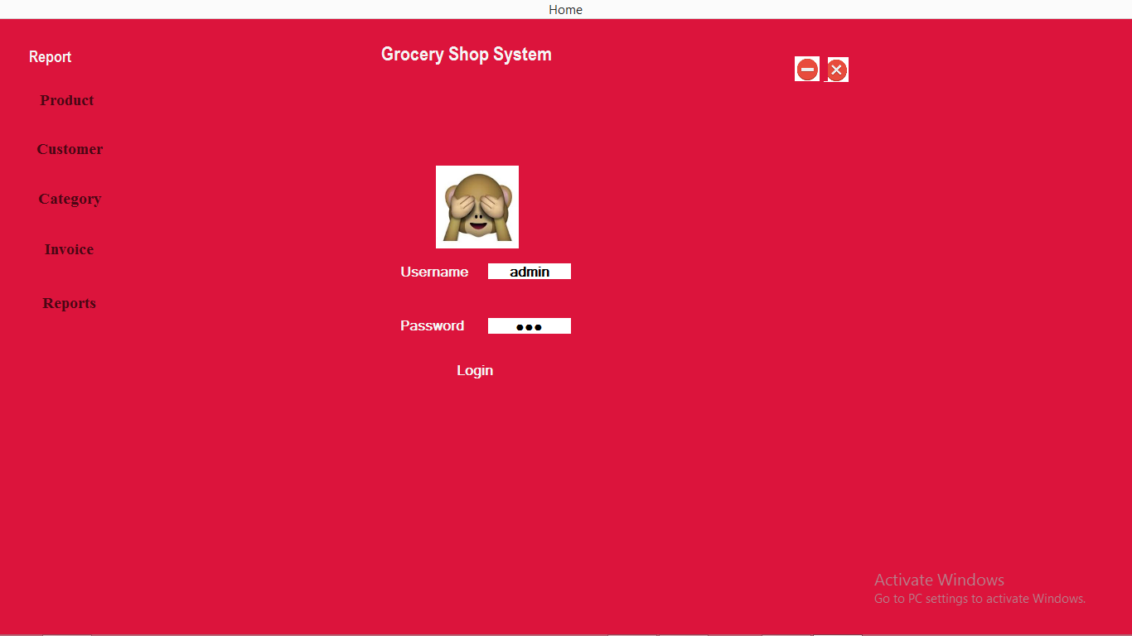

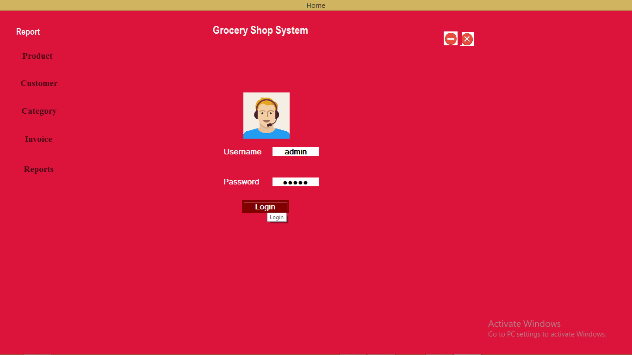

Registration

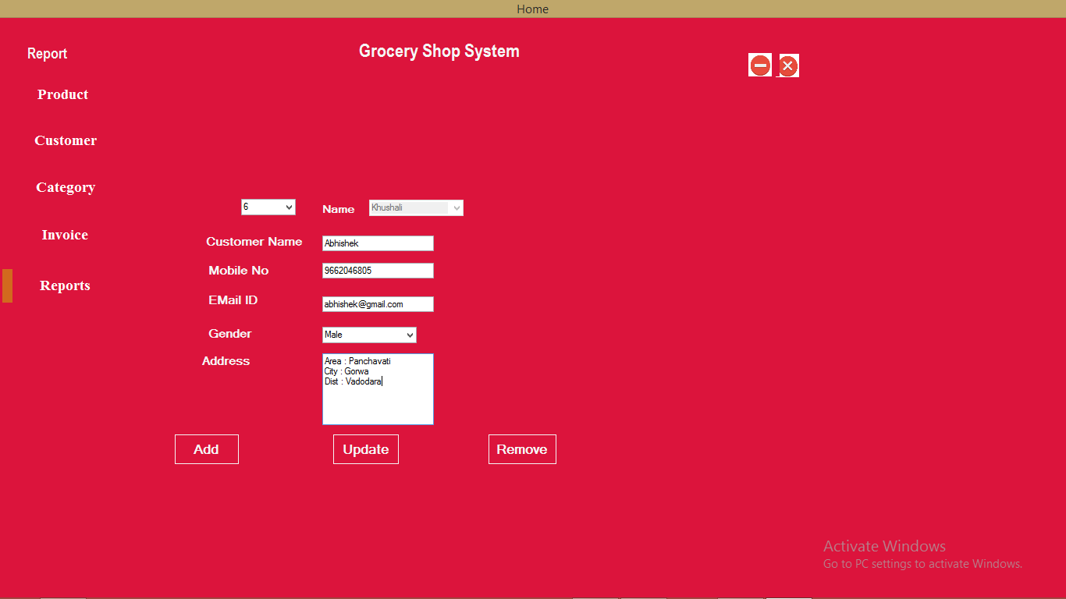

Product Manage

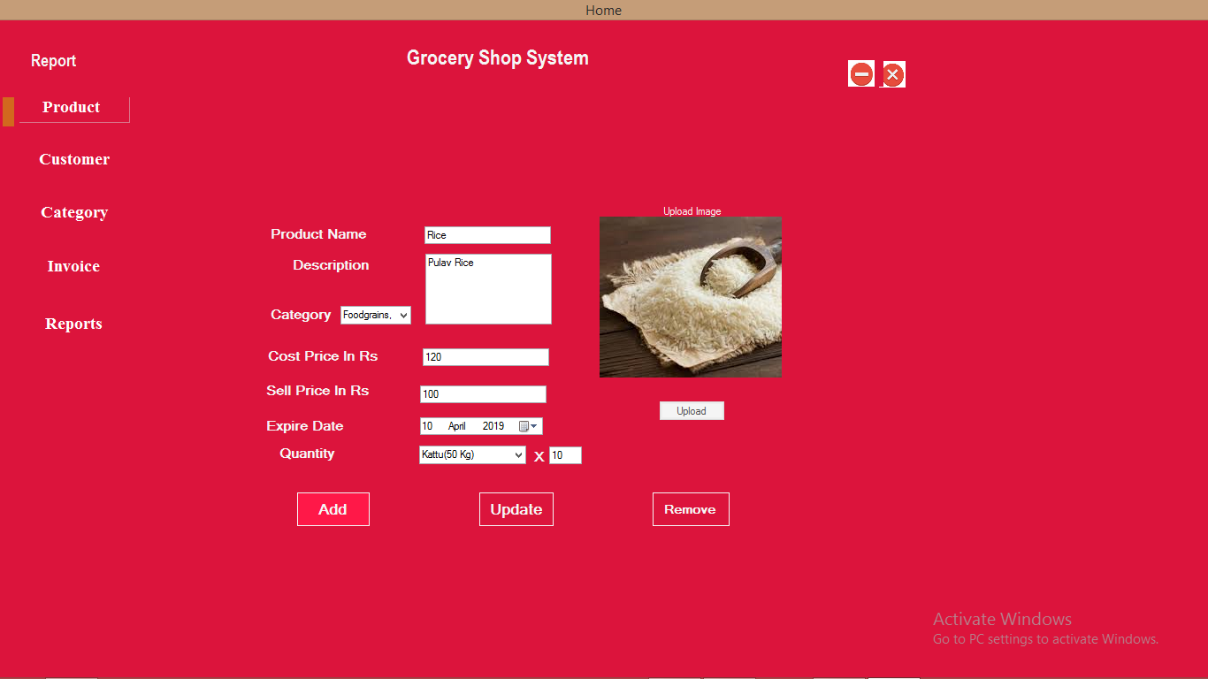

Add Category

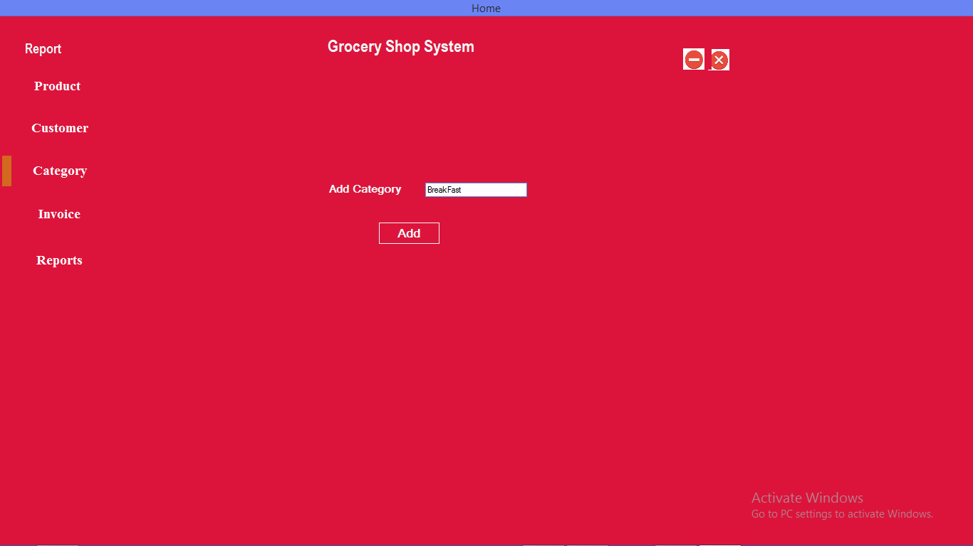

Order

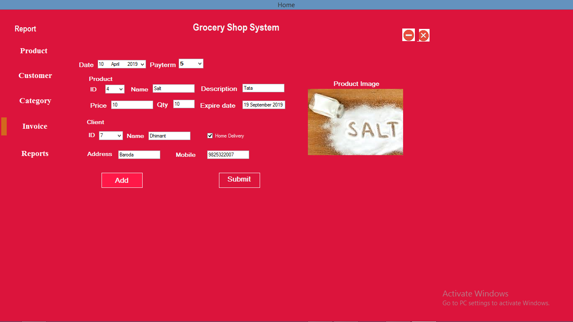

Invoice

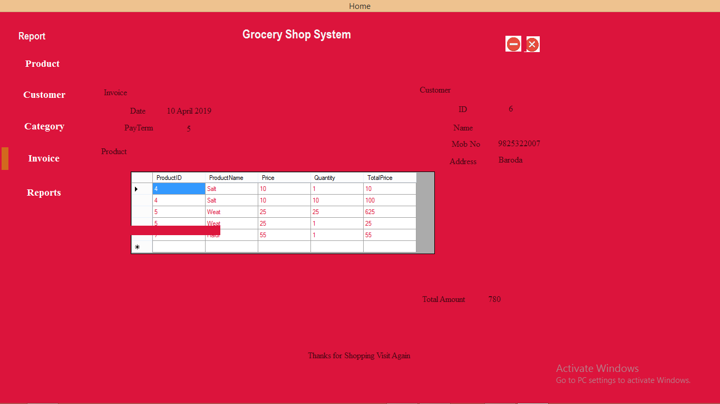

Reports

